Private Elmer Warman
1st Infantry Division
Omaha Beach

1930 Census
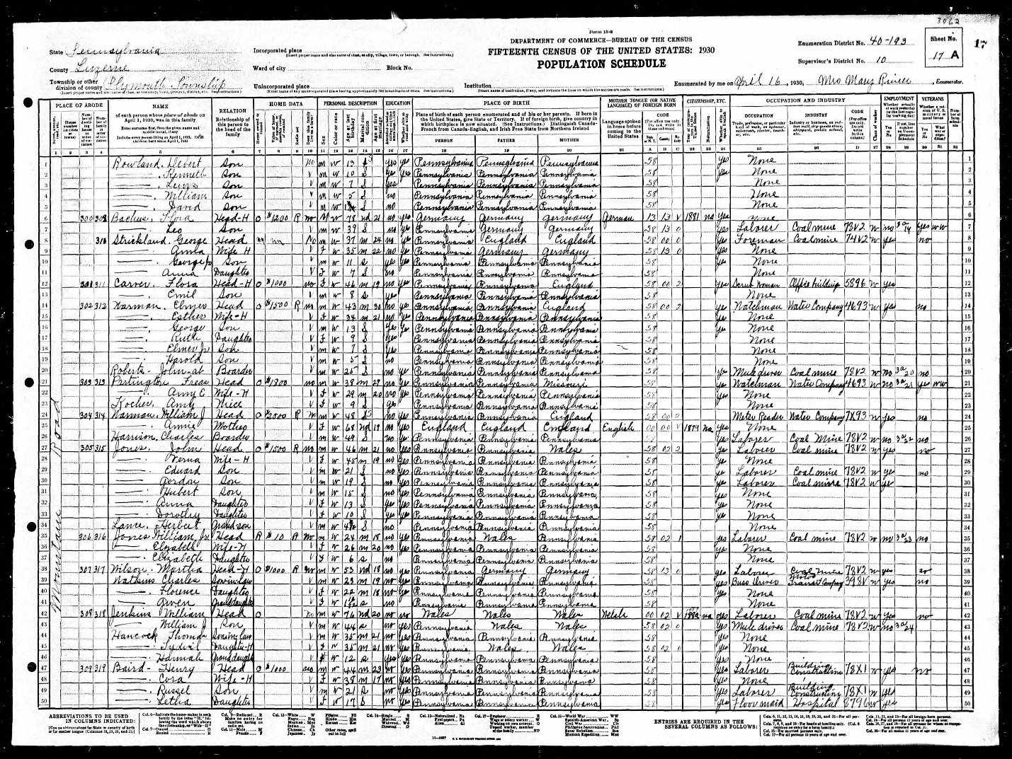

Draft Registration Card

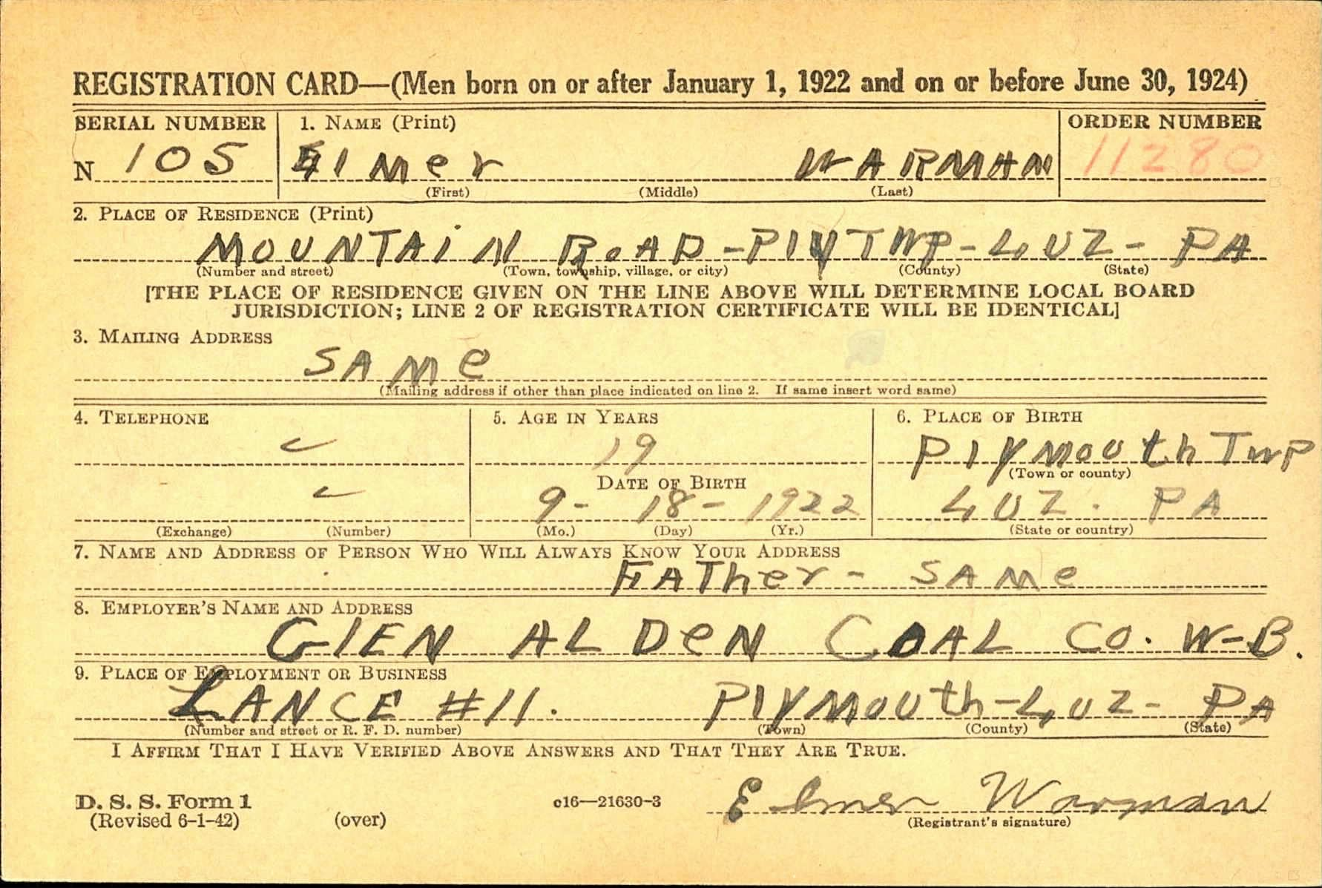

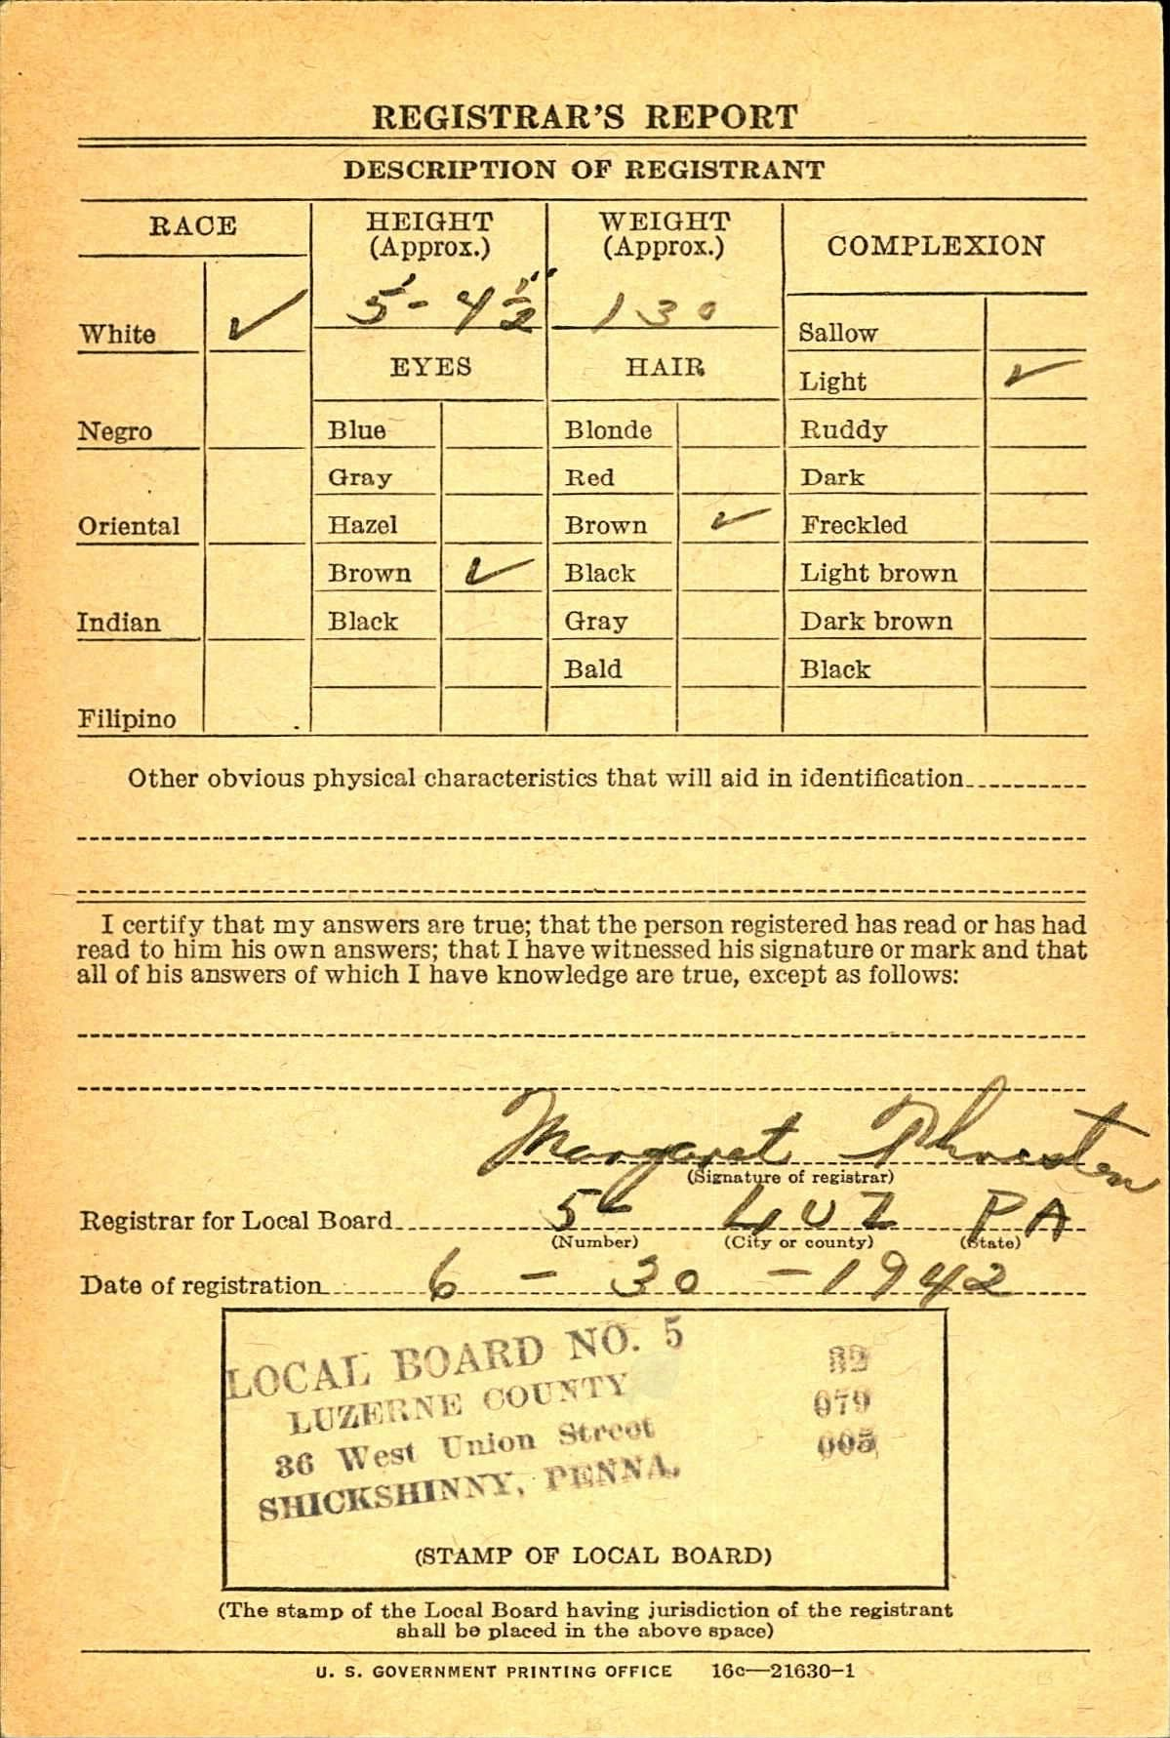
Cemetery Interment Form

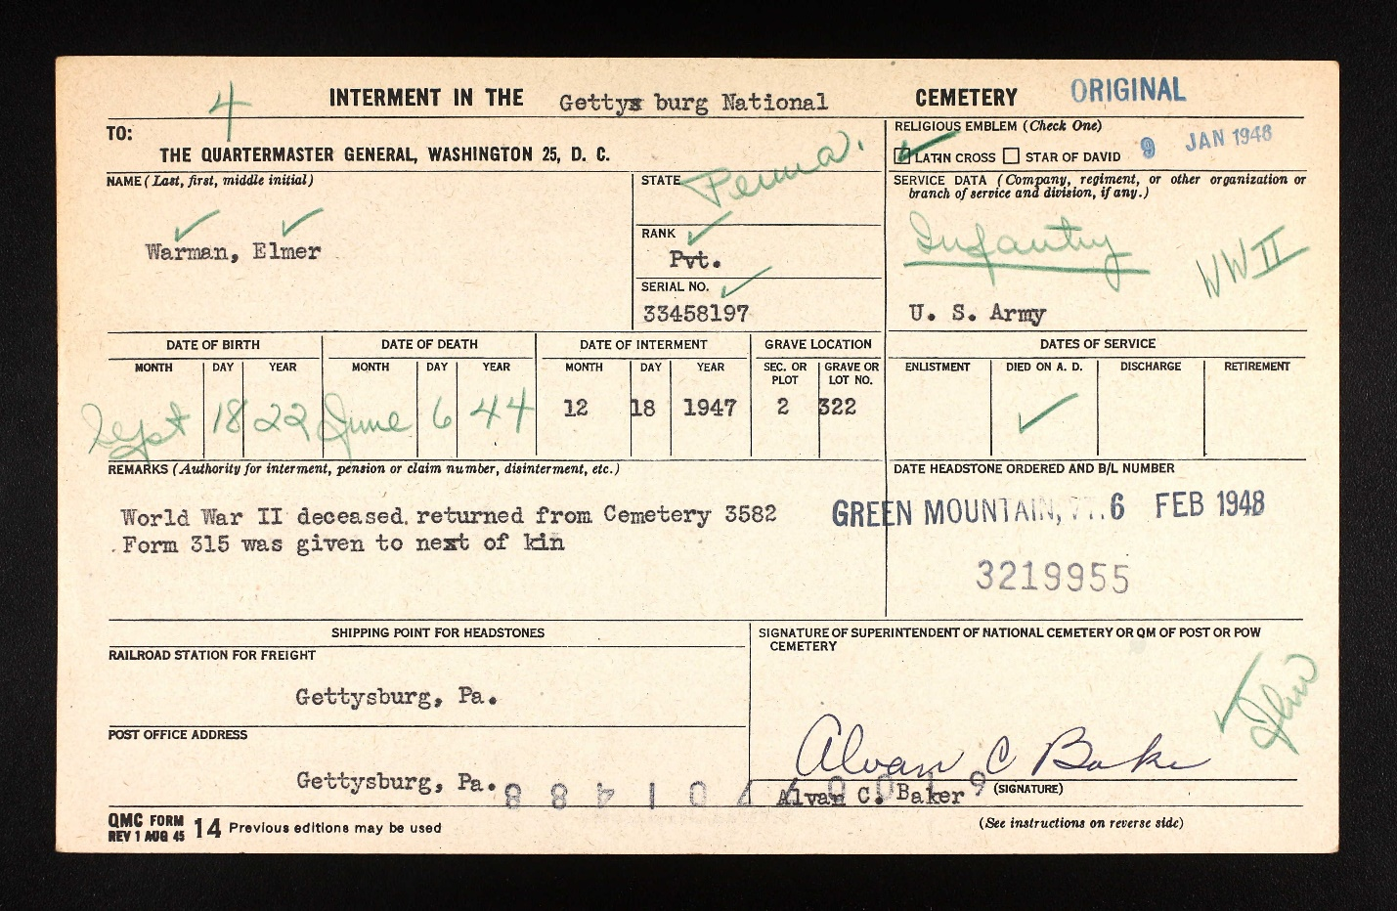

Wilkes-Barre Record newspaper, June 29, 1943
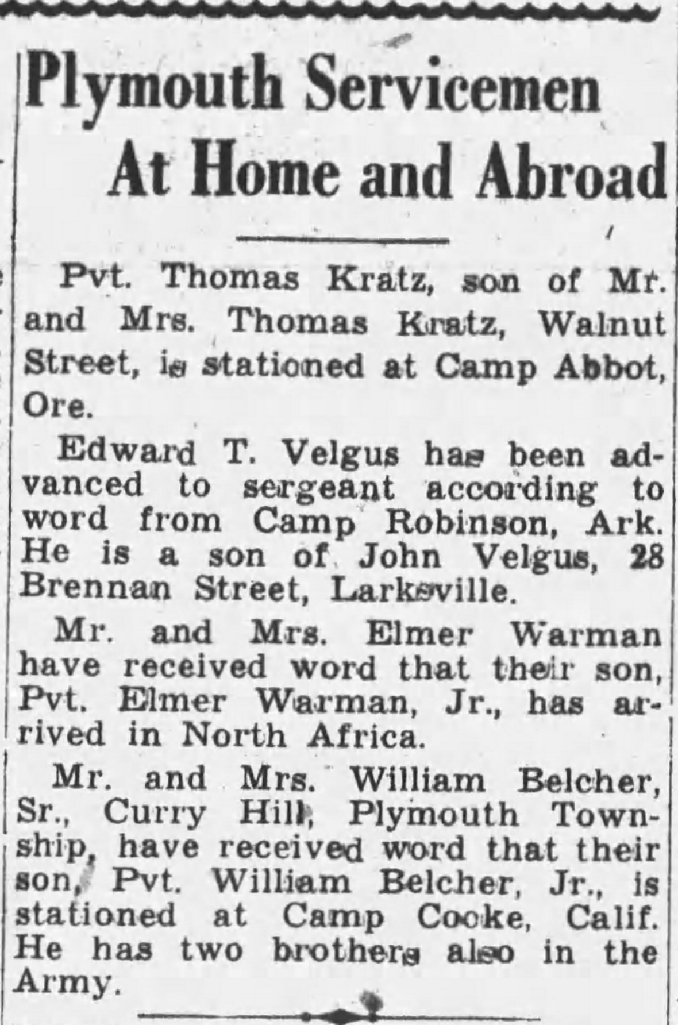

Wilkes-Barre Times Leader, December 1, 1944

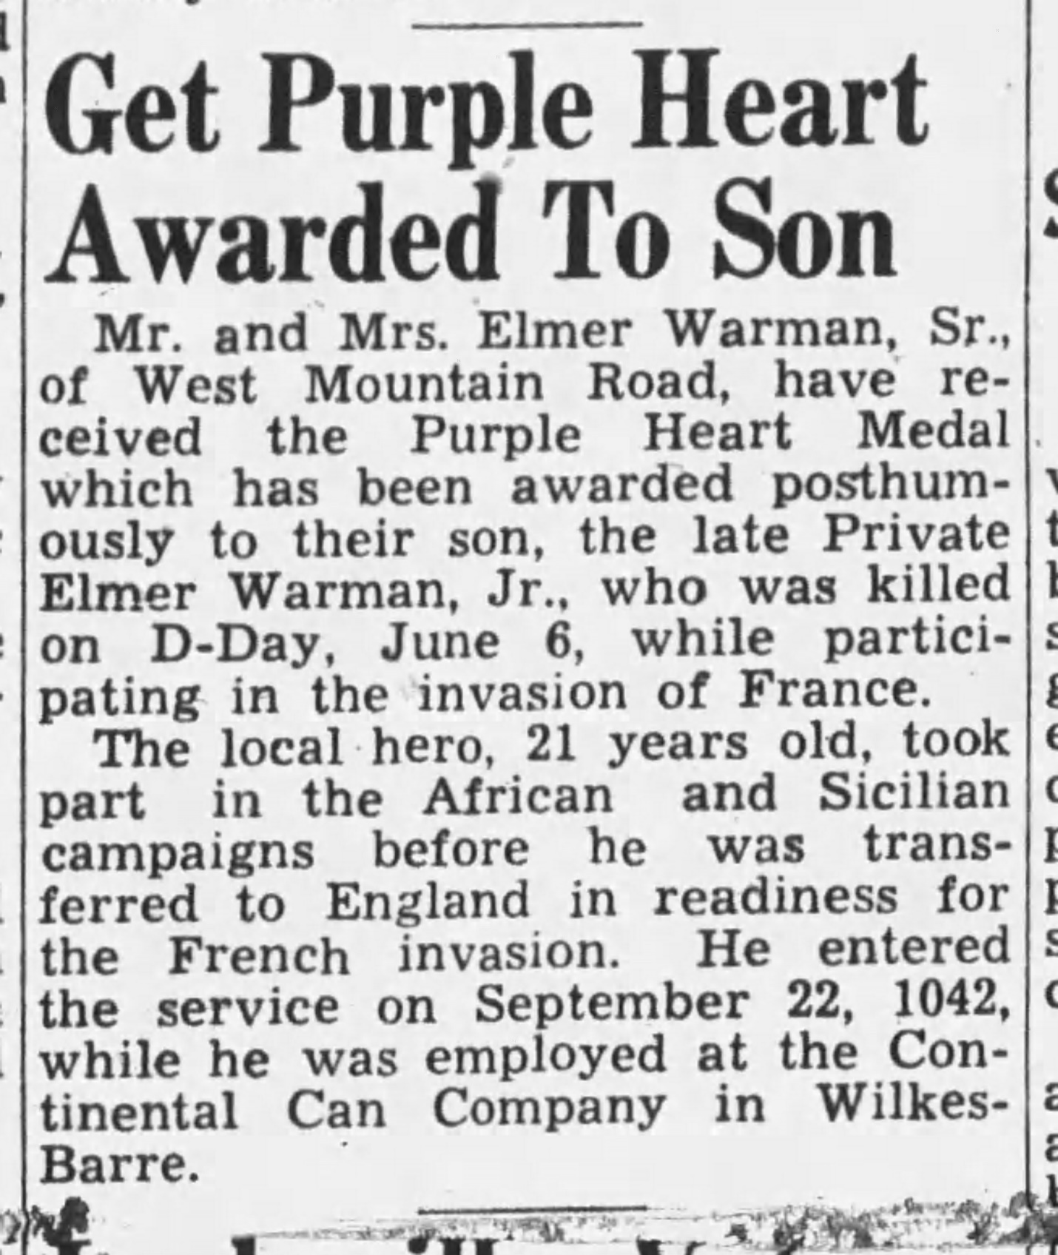

Wilkes-Barre Leader, December 17, 1944
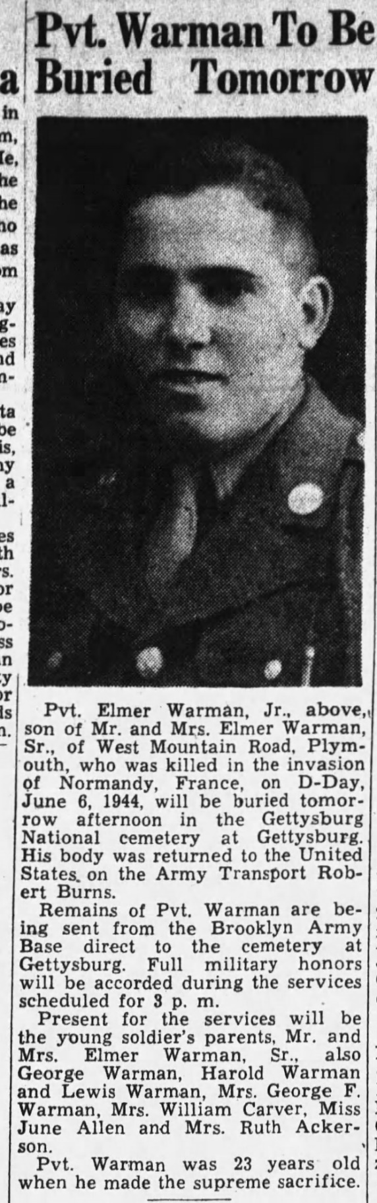

Wilkes Barre Times Leader, April 18, 1944
